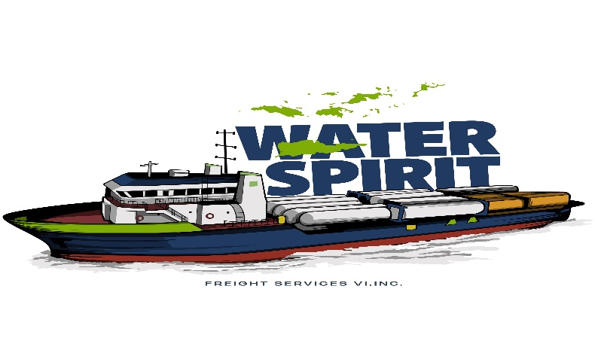

MUELLE 10 PUERTA DE TIERRA SAN JUAN, PUERTO RICO 00901
TEL: 787-722-0548

REQUIRED DOCUMENTS TO EXPORT VEHICLES AND / OR HEAVY EQUIPMENT TO USVI

- Copy of vehicle title and copy of registration. If still financed, notarized letter from financial institution authorizing the export. At this moment only Pentagon Federal Credit Union is authorizing vehicles still financed to be exported.

- Certificate of the Department of Motor Vehicles (DTOP / CESCO), that vehicle has no outstanding tickets. Expires in 3 calendar days from date of issue. (Form DTO-DIS-224 & DTO-DIS-234). For both forms stamps are needed ($ 11.00 – code 5120 and $ 2.00 – code 842)

- For vehicles – Export stamp ($10.00 – code 5122) from the Excise Tax Agency (Colecturia).

For Heavy Equipment / Machinery – Export stamps ($50.00) from Excise Tax Agency (Colecturia)

$ 2.00 (code stamp 842) – Donativo Centro de Trauma

- Proceed to the Police Department Stolen Vehicle Division for PRE – INSPECTION. This is done in the police zone of the address where vehicle is registered. Notarized letter will be required if the actual owner of vehicle is not present for inspection. Expires in 5 calendar days from date of issue.

- Certificate of negative of assessment provided by the ACAA office. Expires in 30 calendar days from date of issue.
ACAA
249 Arterial Hostos
San Juan, Puerto Rico
(Corner of Chardon Ave. / In front of Federal Court)
787-759-8989

- Visit a notary office of your preference and prepare a sworn statement declaration in which it authorizes our company, WATER SPIRIT FREIGHT SERVICES to do the transport of your vehicle and/or equipment. If it’s a corporate vehicle a corporate resolution will be required.

- Bring to our office all documents in order for us to provide the export documents (bill of lading) for the inspection to be performed by US Customs.

- The original bill of lading and all required shipping documents and vehicle must be taken to US Customs for inspection. US Customs inspections are performed Tuesdays and Thursdays between 1pm – 3pm only. Notarized letter will be required if the actual owner of vehicle is not present for inspection.
US Customs
Zona Libre de Comercio (Free Trade Zone)
Building # 2
Guaynabo, Puerto Rico
787-774-4104

- Once the vehicle is given US Customs authorization, the vehicle must be delivered to our facilities with all original documents . By federal regulation vehicle has to be received at least 72 hours before shipping (Thursday before 4pm.)

- Once we receive all documents we will proceed to send all documents to the Police Stolen Vehicle Department for them to perform final inspection at port and authorize the export.

